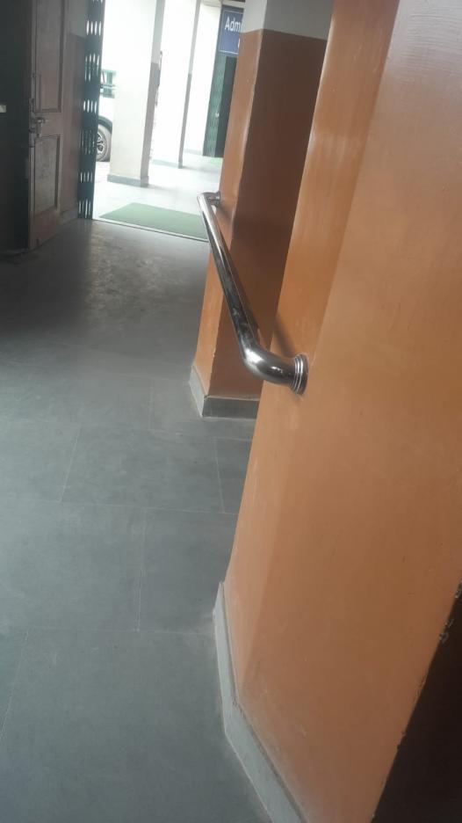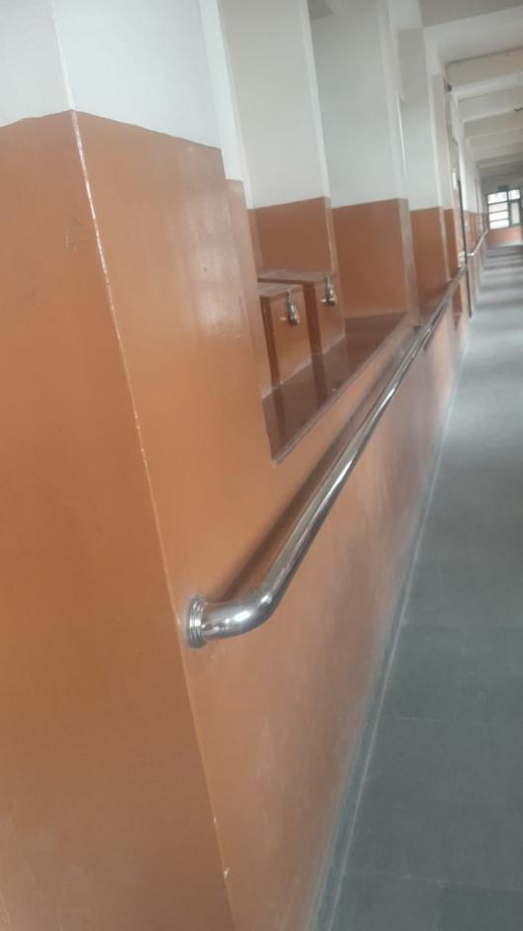

Ramps and railing for special girls

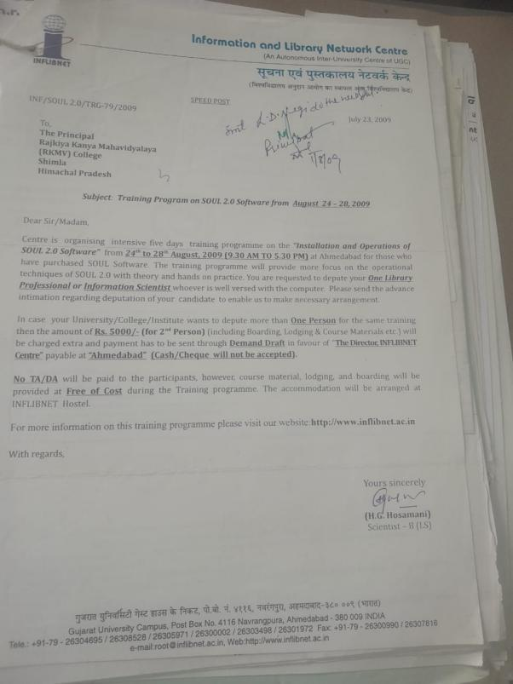

Digital library with Soul 2.0 software

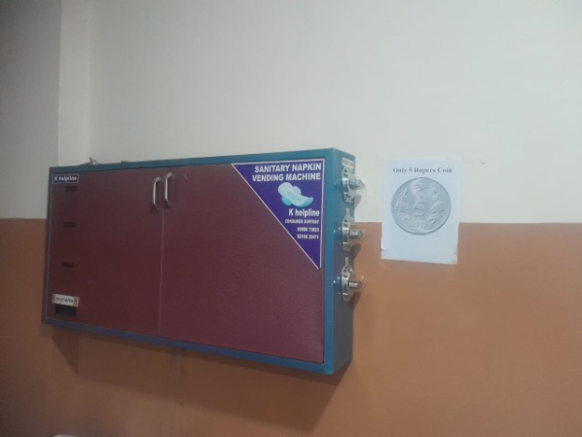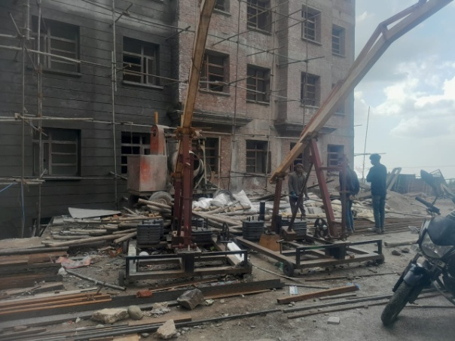

Due to the ongoing construction of the new building which is on the verge of completion students will be able to practice sports in the open space which at present is not available to them as construction material is still there.

Sanitary pads facility